12.4 Transition metal
Name: ____________________ Class: ____________________ Due date: 3.20
1. The diagram shows an outline of part of the Periodic Table.
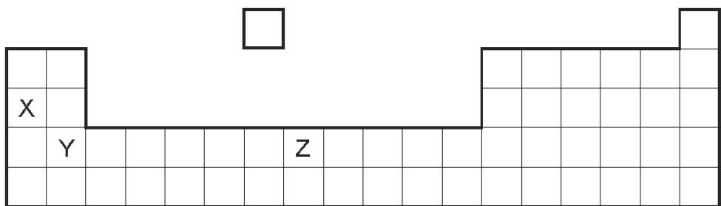
Which statement about elements X, Y and Z is not correct? （ ）
A All are metals.
B All conduct electricity.
C All form coloured compounds.
D All react with oxygen.

2. Which properties of the element titanium, Ti, can be predicted from its position in the Periodic Table? （ ）
 | can be used as a catalyst | Conducts electricity when solid | has low density | forms coloured compounds
A | ✓ | ✓ | ✗ | ✓
B | ✓ | ✓ | ✓ | ✗
C | ✓ | ✗ | ✓ | ✓
D | ✗ | ✓ | ✓ | ✓

3. The positions of four elements are shown on the outline of the Periodic Table.
Which element forms a coloured oxide? （ ）
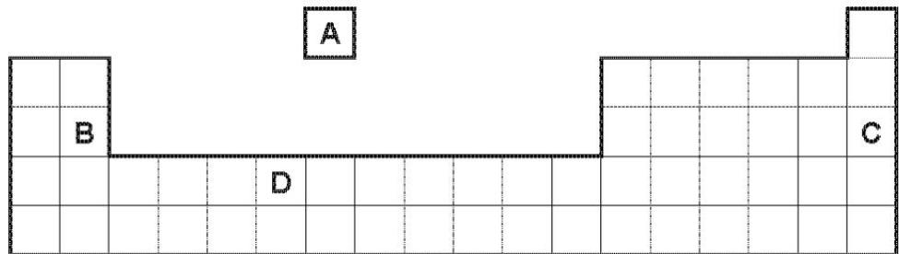

4. Platinum is a transition metal.
Which statement about platinum is correct? （ ）
A It does not catalyse reactions.
B It forms coloured compounds.
C It has a low density.
D It has a low melting point.

5. An element has a melting point of ${1084}^{∘}C$ and a density of $8.93g/cm^{3}$ . It’s oxide can be used as a catalyst.
In which position in the Periodic Table is the element found? （ ）
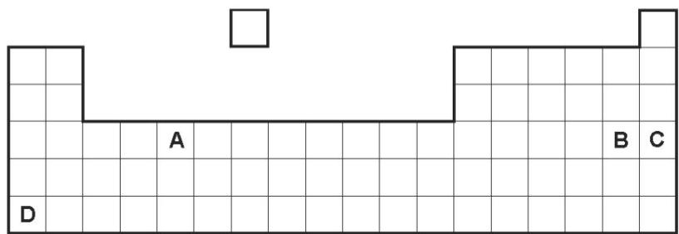

6. M is a shiny silver metal. It has a melting point of ${1455}^{∘}C$ .
Many of its compounds are green.
What is metal M? （ ）
A aluminium B copper C mercury D nickel

7. Which properties of the element titanium, Ti, can be predicted from its position in the Periodic Table? （ ）
 | can be used as a catalyst | conducts electricity when solid | has low density | forms coloured compounds
A | ✓ | ✓ | ✓ | x
B | ✓ | ✓ | x | ✓
C | ✓ | x | ✓ | ✓
D | x | ✓ | ✓ | ✓

8. Which of the following could be a transition element? （ ）
 | melting point in℃ | density in g/cm³ | colour | electrical conductor
A | 114 | 4.9 | purple | no
B | 659 | 2.7 | grey | yes
C | 1677 | 4.5 | grey | yes
D | 3727 | 2.3 | black | yes

9. Which statement about transition elements and their compounds is correct?（ ）
A All the transition elements have an oxidation state of $+2$ only.
B Aqueous solutions of the salts of transition elements are generally coloured.
C Transition elements change from metal to non- metal across the period.
D Transition elements can act as catalysts but their compounds cannot.

10. Which row describes the properties of a transition element? （ ）
 | property 1 | property 2
A | forms colourless compounds | acts as a catalyst
B | forms colourless compounds | low electrical conductivity
C | high density | acts as a catalyst
D | high density | low electrical conductivity

11. Which pair of compounds shows that transition elements have variable oxidation states? （ ）
A ${Cr}_{2}O_{3}$ and ${CrBr}_{3}$ B ${CuSO}_{4}$ and ${CuCl}_{2}$ C ${Fe}_{2}O_{3}$ and ${FeCl}_{2}$ D $NiO$ and ${NiCl}_{2}$

12. Iron reacts with dilute hydrochloric acid to form iron(II) chloride, ${FeCl}_{2}$ . Iron reacts with chlorine to form iron(III) chloride, ${FeCl}_{3}$ .
Which property of transition elements is shown by this information? （ ）
A Transition elements have high melting points.
B Transition elements can act as catalysts.
C Transition elements have variable oxidation states.
D Transition elements have coloured compounds.

13. Transition elements can have variable oxidation states.
Which pair of compounds shows a transition element in two different oxidation states? （ ）
A ${Cr}_{2}O_{3}$ and ${Cr}_{2}({SO}_{4})_{3}$
B ${Cu}_{2}O$ and ${CuCO}_{3}$
C ZnS and $ZnSO_{4}$
D NiO and $Ni(NO_{3})_{2}$

14. Vanadium is a transition element. It has more than one oxidation state. The element and its compounds are often used as catalysts.
Complete the electron distribution of vanadium by inserting one number.
$$2+8+………+2$$
Predict three physical properties of vanadium which are typical of transition elements.
...........................................................................................................................................................................................................................................................................[2]

The oxidation states of vanadium in its compounds are $V(+5)$ , $V(+4)$ , $V(+3)$ and $V(+2)$ . The vanadium(III) ion can behave as a reductant or an oxidant.
Indicate on the following equation which reactant is the oxidant.
$$2V^{3+}+Zn→2V^{2+}+Zn^{2+}$$
Which change in the following equation is oxidation? Explain your choice.
$$V^{3+}+Fe^{3+}→V^{4+}+Fe^{2+}$$
...........................................................................................................................................................................................................................................................................................................................................................................................................................................................................................................................................................[2

15. The table gives some chemical properties of transition elements and their compounds, and of Group I elements and their compounds.
chemical property | transition elements | Group I elements
ability to act as catalysts | yes | no
exist as coloured compounds | yes | no
What is meant by the term catalyst?
...............................................................................................................................
Give one other chemical property shown by transition elements which is not shown by Group I elements.
...............................................................................................................................
Give two physical properties shown by transition elements which are not shown by Group I elements.
1 ...............................................................................................................................
2............................................................................................................................... [2]

